Security project
(Three Multi-letter Encryption)
(RSA Encryption)

St.name: Ammar 'mohamed basem' jawdet alnatsheh.
Dr.name: Khaleel alhinde
Class: Security 2005 From 10-11

Introduction:
By increasing development in the computer science area in the world, and research working in the distributed and sharing system become bigger and global. Every one now can access to the computers network and load the data and information give him away to read the security information for these company, so the needs to cipher the information and only read from the major came to important.

Description
The problem as we saw represent the way to keep the information invisible from the opponent, actually there is a lot of ideas found in this domain and we choose the three multi-letter encryption method.
This method is popular case its simple and don’t need a special resources. And need a lot of time and money to break it, so it's used by people who don’t need that secure information for along time. Its work by getting three letters each time and encrypted them to gather using small key.

Algorithm works

- 3 multiple letter encryption
This method depends on getting the plaint text letter 3 by 3 and encrypts it as one group, in our work we get the numbers and normal letters then order it as groups to apply the mathematical operation on them.
C = ( P * K ) Mod 46663
P = ( C * K¯ ) Mod 46663

And this method used as encryption1 function in this program.

- RSA algorithm.
This method depends on getting the plaint text letter 1 by 1 and encrypts it, in our work we get the numbers and normal letters to apply the mathematical operation on them.
K

C = ( ( P ) ) Mod 47053
K¯
P = ( ( C ) ) Mod 47053

47053 = 211 * 223
- ф(47053) = 210 * 222 = 46620
- K * K¯ Mod 46620 = 1

And this method used as encryption2 function in this program.

Finally
For following the development in the security and cryptography area we try to simulate the three multi-letter encryption methods and work with it.
And we advice it for normal security level.

User manual:

- Main interface

This menu bar to include user optional

This area to write the text in it ( cipher or plain text)
This area to display the text in it ( cipher or plain text)

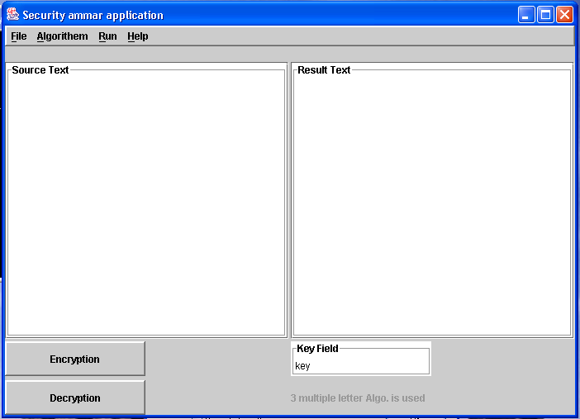

This label to know the algorithm is use, and the public key in RSA algo.
This area to write the key value

This buttons used to (encrypt or decrypt) the text in the source area and write the result in the result area

2. Menus in the menu bar:

a. File Menu b. Algorithm Menu
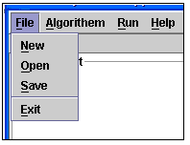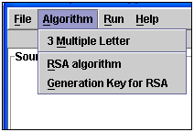

c. Run Menu d. Help Menu
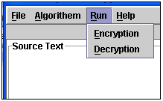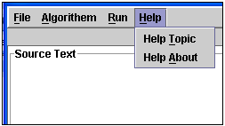

Menu items and there works:
- New: to create anew file.
- Open: to open an exist file.
- Save: to save this file.
- Exit: exit the program.
- 3 multiple letter: encrypt the source text as 3 multiple letter algorithm.
- RSA algorithm: encrypt the source text as RSA algorithm.
- Generation key for RSA: to generate public and private keys can be use in this program.
- Encryption: encrypt the source text using key value.
- Decryption: decrypt the source text using key value.
- Help Topic: show some information about the program and its work.
- Help About: show information about programmer ID.

Programmer manual:

Main
Start
End
Encryption2
Encryption1
Reflection
De_reflection
Key
Open
Close
Save
New
Exit
Key_generation
Analysis

- Main: the main user interface which can choose the option from it and display information on it.
- New: to create anew file.
- Open: to open an exist file.
- Save: to save this file.
- Exit: exit the program.
- Encryption1: apply the 3multiple letter algorithm.
- Encryption2: apply the RSA algorithm.
- Reflection: know the order of three group letters.
- De_reflection: know the three group letters from its order.
- Key : translate the characters in the key field to integer number.
- Key_generation: generate private and public key can used in this program.
- Analysis : to do the modular power and give it as integer for encryption2 ( RSA algo.)

